# Guide to map a server

The mapping is using the Windows File Explorer. This is commonly a quick access application button on the bottom of the screen, depicted as a folder (red box in the image below) or can be searched in the Windows search box (yellow box below).

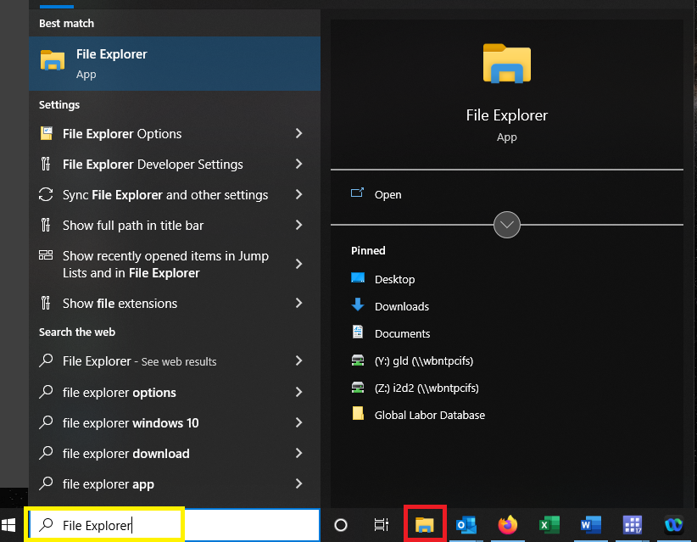

Within the File Explorer, the Network Access is usually at the bottom of the options on the left-hand frame (see option highlighted yellow in screenshot below).

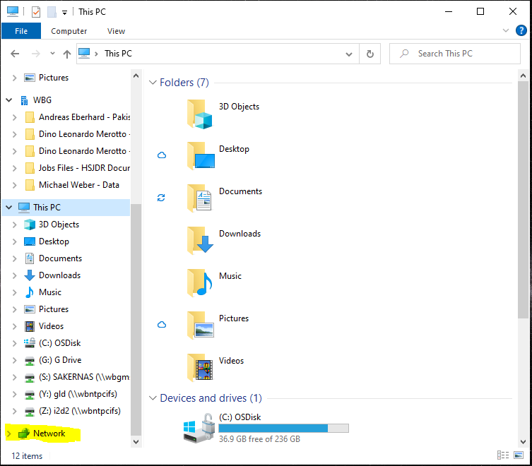

Commonly, World Bank Windows environments do not allow to use primary click on this option. If this is done the error shown below will pop up.

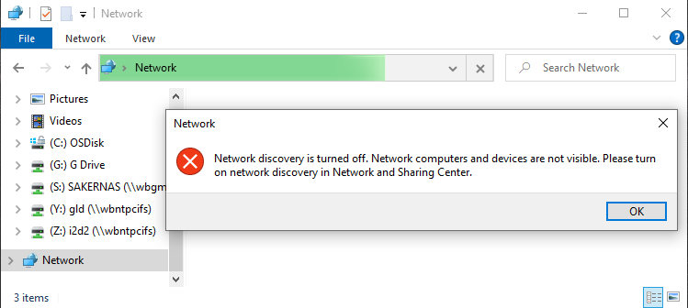

Thus, within the File Explorer (framed yellow below) find the “Network” option and use secondary click (right-click) on it. Then a pop-up appears giving different options. Click on “Map network drive…” (green box).

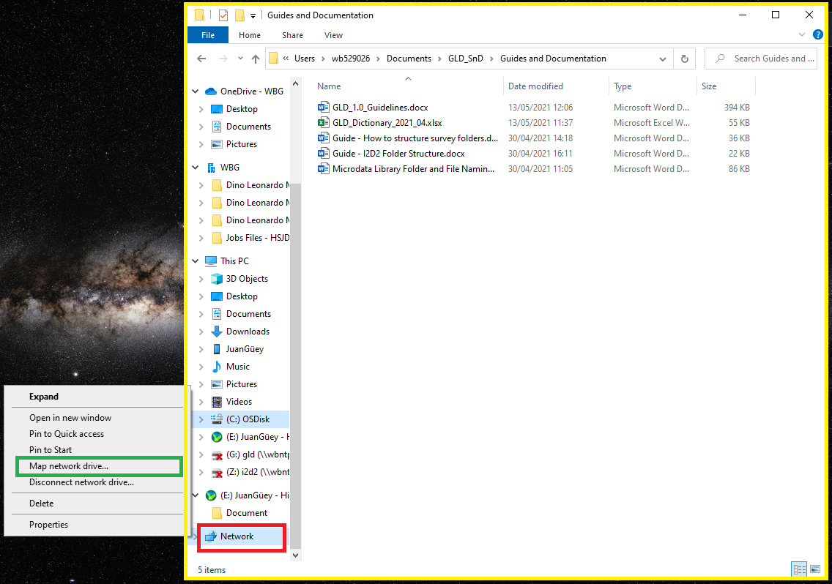

This will in turn cause another pop-up window to appear (shown below). You need to select what letter the mapped drive ought to have by choosing a letter (drop down box appears by clicking on the arrow in the red box – use any letter except G, which is used behind the scenes by IT, we recommend Y for GLD).

You also need to define the address the mapping should go to (green box). The two servers we will be working with are:

\\wbntpcifs\gld

\\wbntpcifs\i2d2

Most users, however, will have access only to the public GLD surveys. These users should map GLD as:

\\wbntpcifs\gld\gld-public

Once you have typed any one in, the currently greyed out “Finish” button (yellow box) should become available. Click on it and the process should be complete.

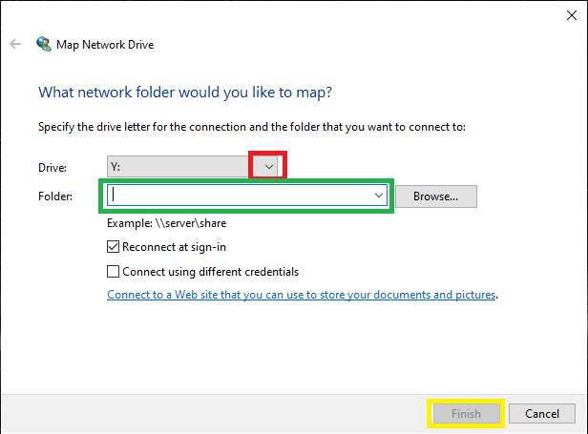

After finishing the new servers should be added and available under the “This PC” (or your name for your device) header.

